Year 9 Earth Science

Test Revision

- Label the diagram below :

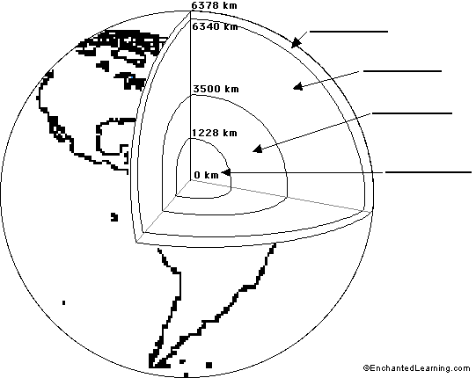

- Explain the theory of continental drift.

- Describe three pieces of evidence we have for continental drift.

- What is the name of the original supercontinent?

- Describe how convention currents form in the mantle.

- Explain the process of seafloor spreading and describe one form of evidence that supports this idea.

- Compare and contrast oceanic and continental crust.

- Use the map below to indicate the location of, and name at least 6 major tectonic plates:

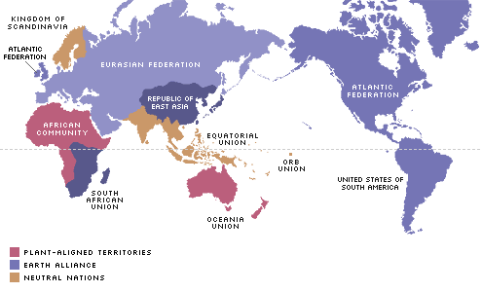

- Compare and contrast the three types of plate boundaries in terms of:
  - Relative movement of plates
  - Evidence on the surface
  - Production or removal of Earth materials

- Explain using diagrams what drives the movement of tectonic plates.

- Explain why Australia is not subject to a lot of tectonic activity.

- Describe how the volcanic islands of Hawaii were formed.

13. Label the following diagram

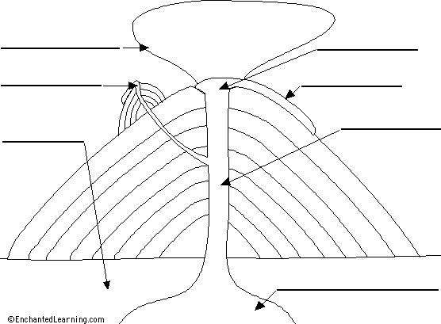

- Plate tectonics quiz

a) ________________________ Upper mantle and crust that is broken into pieces called plates.

b) _______________________ Soft layer of earth that has convection currents in it.

c) _______________________ Individual who proposed Continental Drift Theory.

d) _______________________ Individual who proposed Seafloor Spreading.

e) _______________________ Large land mass or supercontinent.

f) _______________________ A point underground where faulting begins.

g) _______________________ Main chamber that contains the magma.

h)_______________________ The process in which soil becomes saturated with water after an earthquake.

i) _______________________ Discharged from a volcano and disrupts air traffic.

j) _______________________ New ocean floor is created at this boundary.

k) _______________________ 70% of Earth’s volcanoes are in this region.

l) _______________________ The boundary at which crust is neither created nor destroyed.

m) _______________________ The scale used to measure earthquakes.

n)________________________ Power increase by this with one step increase in earthquake magnitude.

o) _______________________ A region experiencing volcanic activity for a long time, e.g.- Hawaii.

p) _______________________ Area in which one plate sinks beneath the other.

15. List the damages caused by the following

Earthquakes | Volcanoes | Tsunamis

